**DIGITAL NURTURE 4.0 DEEP SKILLING JAVA FSE-WEEK1**

**NAME: SIVITHA GUNASEKARAN**

**SUPERSET ID: 6413354**

**WEEK 1: DESIGN PATTERNS AND PRINCIPLES**

**Exercise 11: Implementing Dependency Injection**

**Scenario:**

You are developing a customer management application where the service class depends on a repository class. Use Dependency Injection to manage these dependencies.

**Steps:**

1. **Create a New Java Project:**
   * Create a new Java project named **DependencyInjectionExample**.
2. **Define Repository Interface:**
   * Create an interface **CustomerRepository** with methods like **findCustomerById()**.
3. **Implement Concrete Repository:**
   * Create a class **CustomerRepositoryImpl** that implements **CustomerRepository**.
4. **Define Service Class:**
   * Create a class **CustomerService** that depends on **CustomerRepository**.
5. **Implement Dependency Injection:**
   * Use constructor injection to inject **CustomerRepository** into **CustomerService**.
6. **Test the Dependency Injection Implementation:**
   * Create a main class to demonstrate creating a **CustomerService** with **CustomerRepositoryImpl** and using it to find a customer.

**CODE SAMPLES:**

interface CustomerRepository {

String findCustomerById(int id);

}

class CustomerRepositoryImpl implements CustomerRepository {

public String findCustomerById(int id) {

return "Customer #" + id + " - Rachana";

}

}

class CustomerService {

private CustomerRepository repository;

public CustomerService(CustomerRepository repository) {

this.repository = repository;

}

public void showCustomer(int id) {

System.out.println(repository.findCustomerById(id));

}

}

public class DependencyInjectionExample {

public static void main(String[] args) {

CustomerRepository repo = new CustomerRepositoryImpl();

CustomerService service = new CustomerService(repo);

service.showCustomer(1);

}

}

**MY SCREENSHOT PROOFS:**

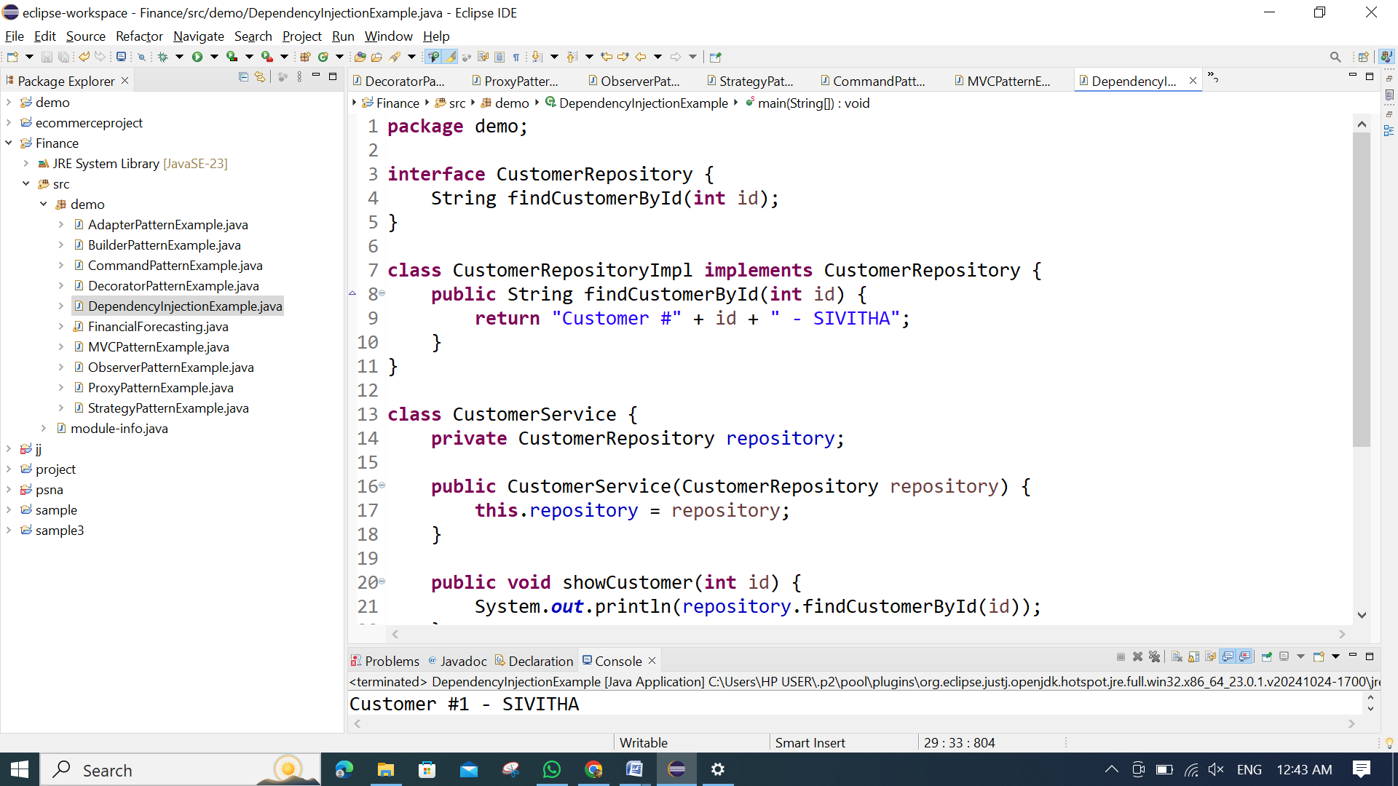

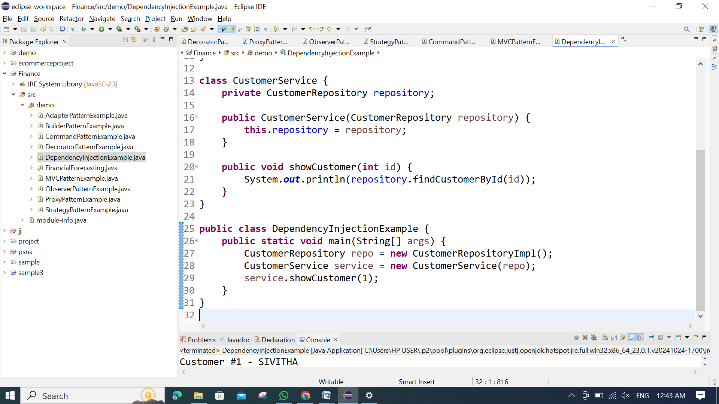

**OUTPUT:**

